# Practical 1: Creating a Database

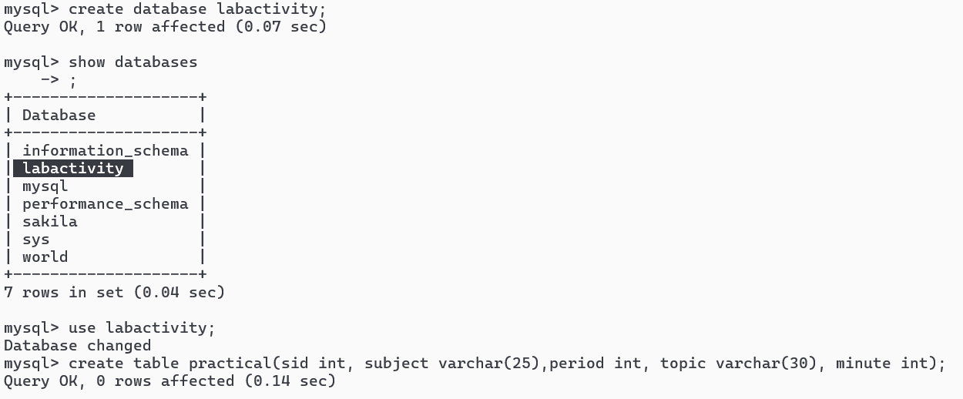

# Practical 2: Insert Records into Table

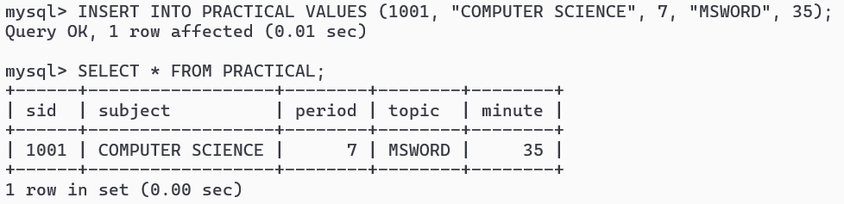

**Program 3: Insert Partial Data**

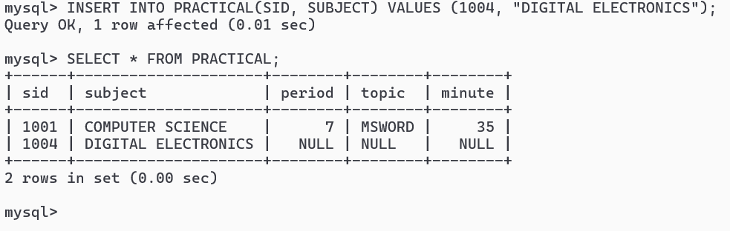

|  |  |
| --- | --- |
| Practical 1: Create Database and Table | Chapter 05: Basic Concepts of Database Management System |
|  | CREATE DATABASE LABACTIVITY;SHOW DATABASES;USE LABACTIVITY;CREATE TABLE PRACTICAL ( SID INT, SUBJECT VARCHAR(25), PERIOD INT, TOPIC VARCHAR(30), MINUTE INT ); |
|  |  |
|  |  |
|  |  |
|  |  |
|  | Practical 2: Insert Records into Table |
| INSERT INTO PRACTICAL VALUES (1001, "COMPUTER SCIENCE", 7, "MSWORD", 35);SELECT * FROM PRACTICAL;INSERT INTO PRACTICAL VALUES (1002, "IT/ITES", 4, "PAINT", 20),(1003, "COMPUTER APPLICATION", 2, "PYTHON", 38);SELECT * FROM PRACTICAL; |  |
|  |  |
|  |  |
|  |  |
|  |  |
|  |  |
|  |  |
|  | **Program 3: Insert Partial Data** |
| INSERT INTO PRACTICAL(SID, SUBJECT) VALUES (1004, "DIGITAL ELECTRONICS");SELECT * FROM PRACTICAL; |  |
|  |  |
|  |  |
|  |  |
|  |  |
|  |  |
|  |  |
|  |  |
|  |  |
|  |  |
|  |  |
|  |  |
|  |  |
|  |  |
|  |  |
|  |  |
|  |  |
|  |  |
|  |  |
|  |  |
|  |  |
|  |  |
|  |  |

# Practical 4: Alter Table and Add Column

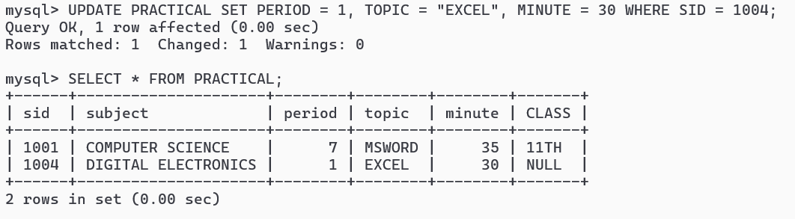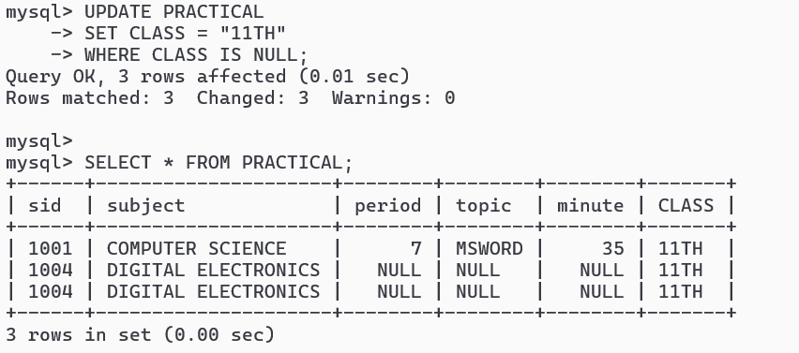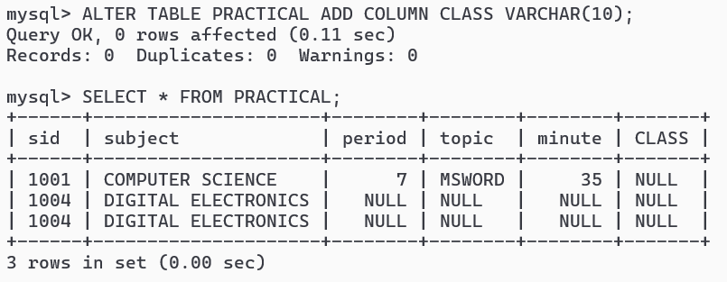

# Practical 6: Update Specific Row

# Practical 5: Update Data with Condition

|  |  |
| --- | --- |
| Practical 4: Alter Table and Add Column | Chapter 05: Basic Concepts of Database Management System |
|  | 11. ALTER TABLE PRACTICAL ADD COLUMN CLASS VARCHAR(10);12. SELECT * FROM PRACTICAL; |
|  |  |
|  |  |
|  |  |
| Practical 5: Update Data with Condition |  |
|  |  |
|  |  |
|  | 13. UPDATE PRACTICAL SET CLASS = "11TH" WHERE CLASS IS NULL;  14. SELECT * FROM PRACTICAL; |
|  |  |
|  |  |
|  |  |
|  | Practical 6: Update Specific Row |
|  |  |
|  |  |
|  | 15. UPDATE PRACTICAL SET PERIOD = 1, TOPIC = "EXCEL", MINUTE = 30 WHERE SID = 1004;  16. SELECT * FROM PRACTICAL; |
|  |  |
|  |  |
|  |  |
|  |  |
|  |  |
|  |  |
|  |  |
|  |  |
|  |  |
|  |  |
|  |  |
|  |  |
|  |  |
|  |  |
|  |  |
|  |  |
|  |  |
|  |  |
|  |  |
|  |  |
|  |  |
|  |  |

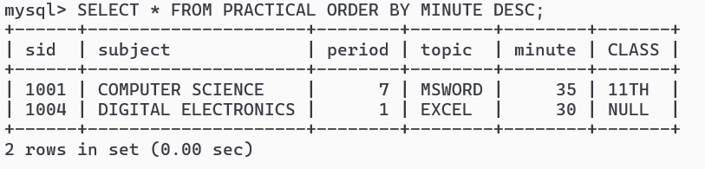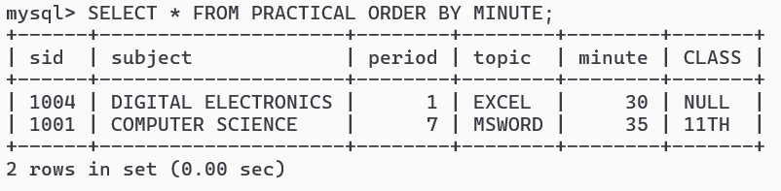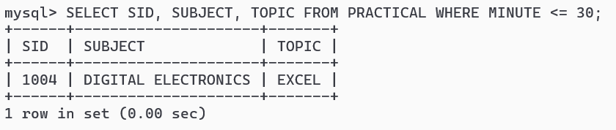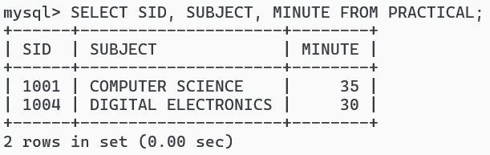

# Practical 10: Sort Records by Minute Descending

# Practical 9: Sort Records by Minute Ascending

# Practical 8: Conditional Data Retrieval

# Practical 7: Display Selected Columns

|  |  |
| --- | --- |
|  | Chapter 05: Basic Concepts of Database Management SystemPractical 7: Display Selected Columns |
|  | 17. SELECT SID, SUBJECT, MINUTE FROM PRACTICAL; |
|  |  |
|  |  |
|  |  |
|  |  |
|  |  |
|  |  |
| Practical 8: Conditional Data Retrieval |  |
|  | 18. SELECT SID, SUBJECT, TOPIC FROM PRACTICAL WHERE MINUTE <= 30; |
|  |  |
|  |  |
|  |  |
|  |  |
|  |  |
|  |  |
|  |  |
|  |  |
| Practical 9: Sort Records by Minute Ascending |  |
|  |  |
|  | 19. SELECT * FROM PRACTICAL ORDER BY MINUTE; |
|  |  |
|  |  |
|  |  |
|  |  |
|  |  |
|  | Practical 10: Sort Records by Minute Descending |
|  |  |
|  | 20. SELECT * FROM PRACTICAL ORDER BY MINUTE DESC; |
|  |  |
|  |  |
|  |  |
|  |  |
|  |  |
|  |  |
|  |  |
|  |  |
|  |  |